Skilling-3

Step1:Go to vuforia and register 190031138

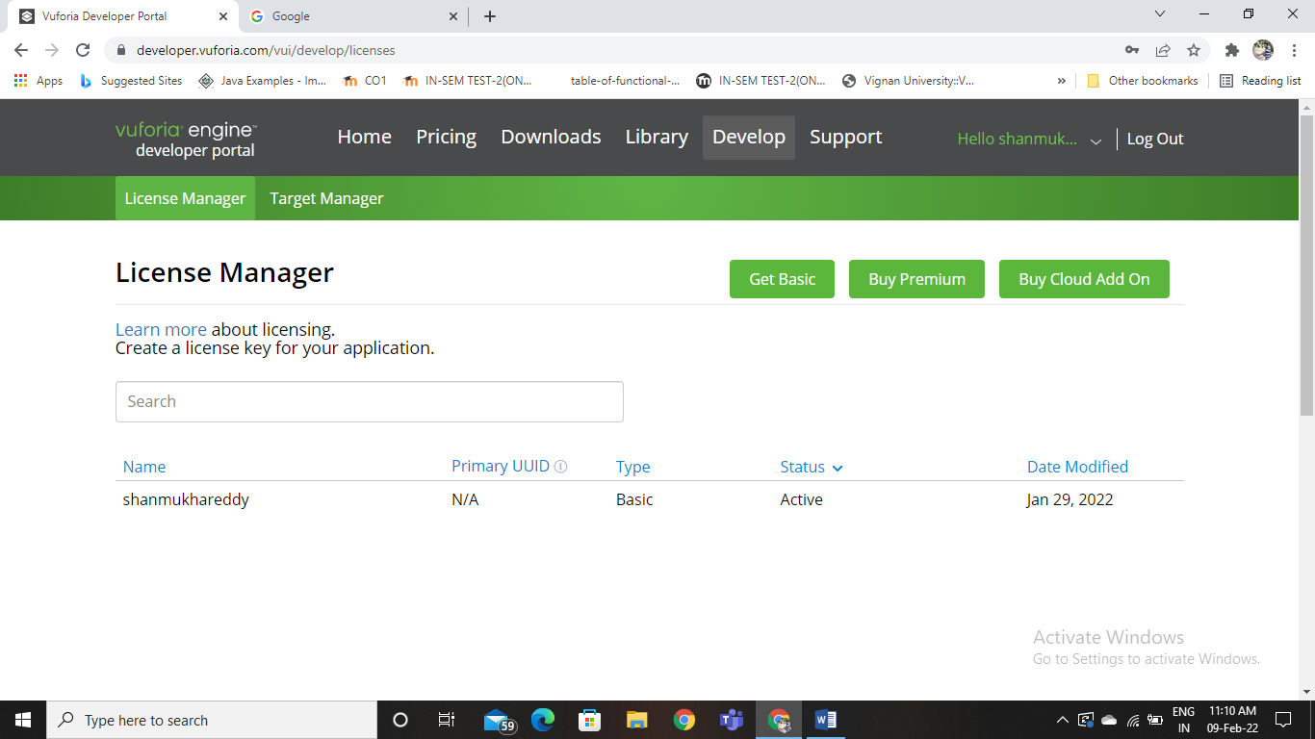

Step2:Create a database in vuforia

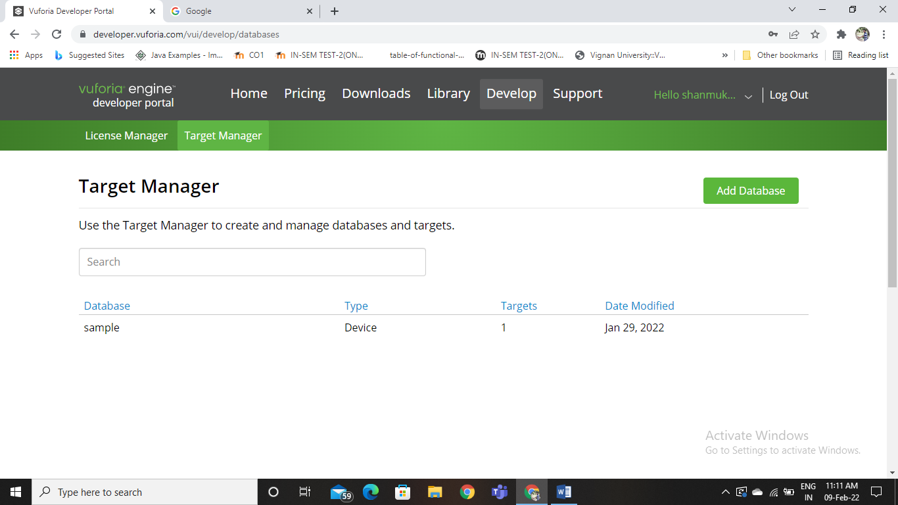

Step3:Download the database

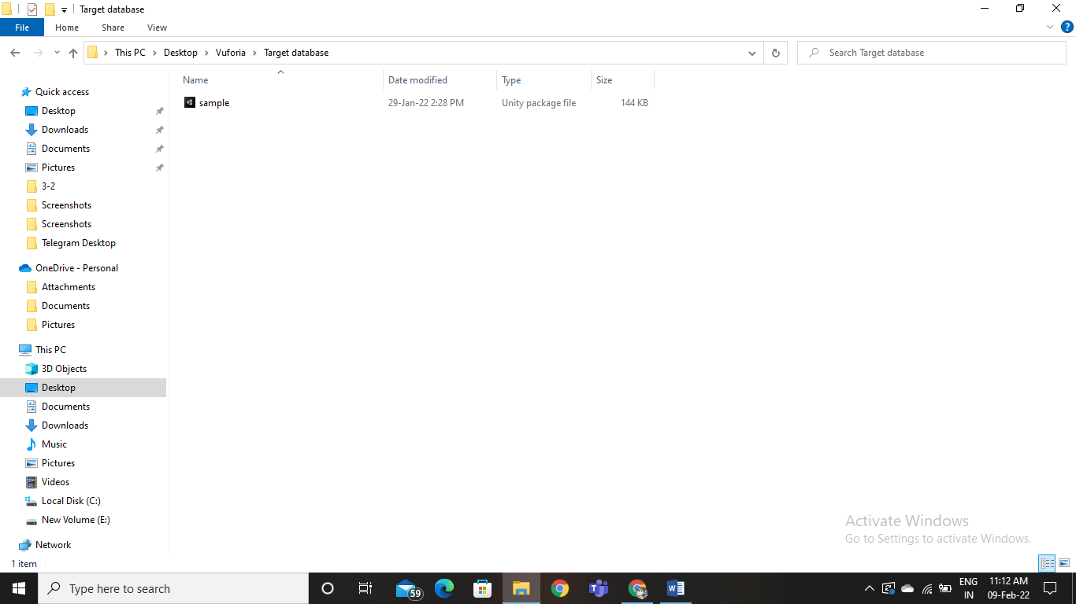

Import it in unity and remove the smple camera and add the ar camera to it

Step4:

Copy the licence key and paste it in right corner of App Licence Key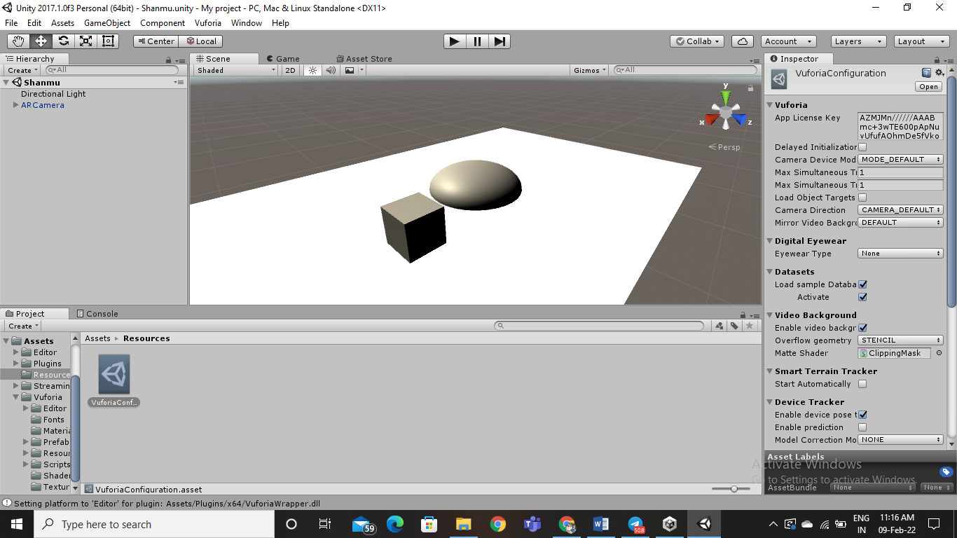

Now Click on play Play button and and show the marker in your marker

